**Experiment no. 3 : To perform various git operations on local and remote repositories using GIT cheatsheet**

**Git Cheat Sheet: Local & Remote Repository Operations**

**Basic Git Commands**

1. Git Configuration

* git config --global user.name "Your Name" → Set your name
* git config --global user.email "youremail@example.com" → Set your email
* git config --list → View Git configurations

Local Repository Operations

2. Initialize and Clone

* git init → Initialize a new Git repository
* git clone <repo_url> → Clone a remote repository

3. Basic Workflow

* git status → Check the status of changes
* git add <file> → Stage a specific file
* git add . → Stage all files
* git commit -m "Commit message" → Commit changes
* git log → View commit history
* git diff → View unstaged changes

4. Branching and Merging

* git branch → List branches
* git branch <branch_name> → Create a new branch
* git checkout <branch_name> → Switch to a branch
* git merge <branch_name> → Merge a branch into the current branch
* git branch -d <branch_name> → Delete a branch

Remote Repository Operations

5. Connect to Remote Repository

* git remote add origin <repo_url> → Connect local repo to remote
* git remote -v → View remote connections

6. Push and Pull Changes

* git push origin <branch_name> → Push local changes to remote
* git pull origin <branch_name> → Fetch and merge changes from remote
* git fetch → Fetch changes from remote without merging
* git add <file> & git commit -m "Resolved conflicts" → Finalize merge

8. Undo Changes

* git reset --hard <commit_id> → Reset to a specific commit
* git revert <commit_id> → Create a new commit that undoes previous changes
* git checkout -- <file> → Discard changes in a file

Useful Commands

* git stash → Save uncommitted changes temporarily
* git stash pop → Restore stashed changes
* git tag -a v1.0 -m "Version 1.0" → Create a tag
* git show <commit_id> → View commit details

By using these commands,we can efficiently manage both local and remote repositories with Git.

**Output of the executed commands**

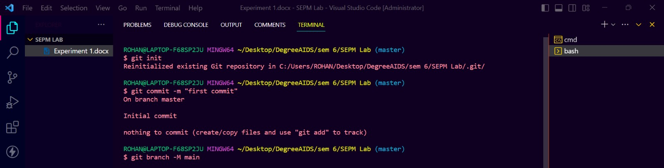

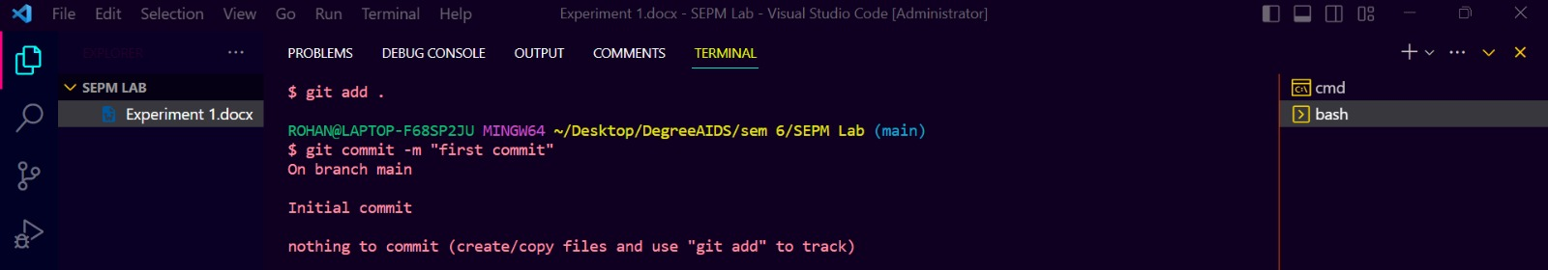

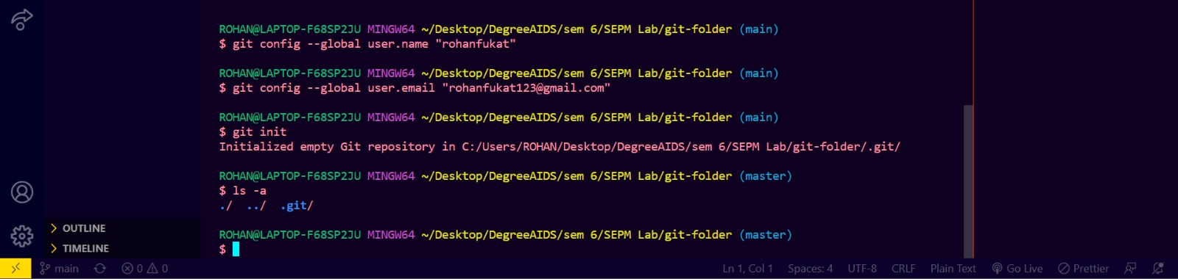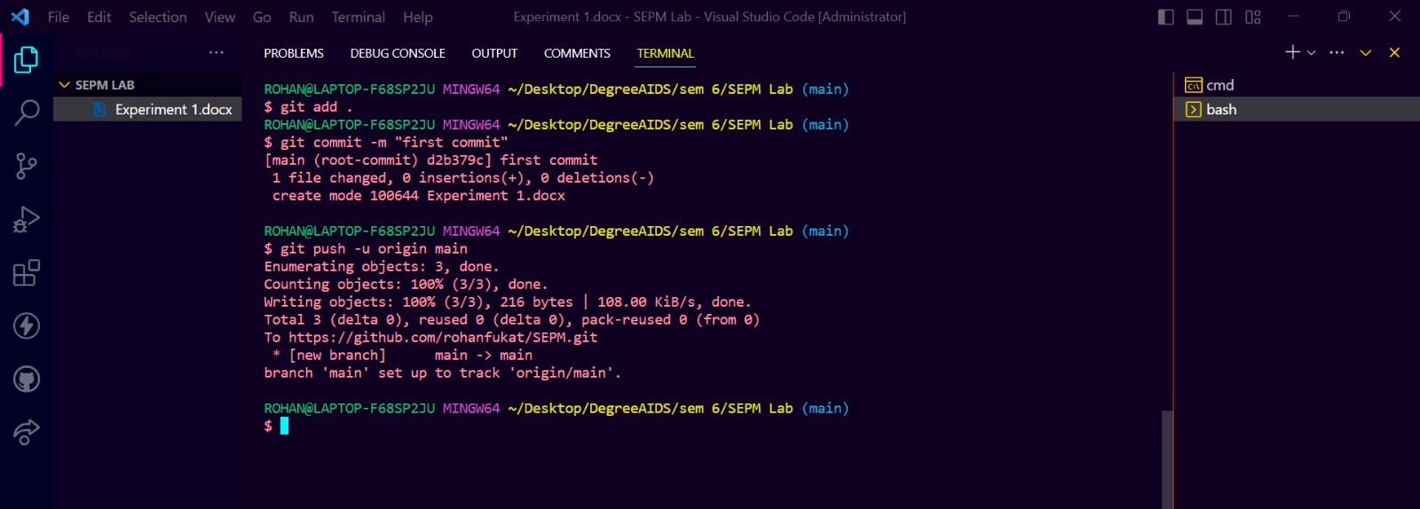

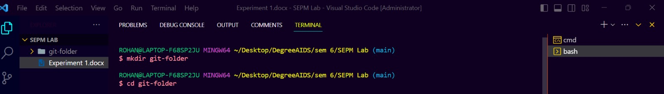

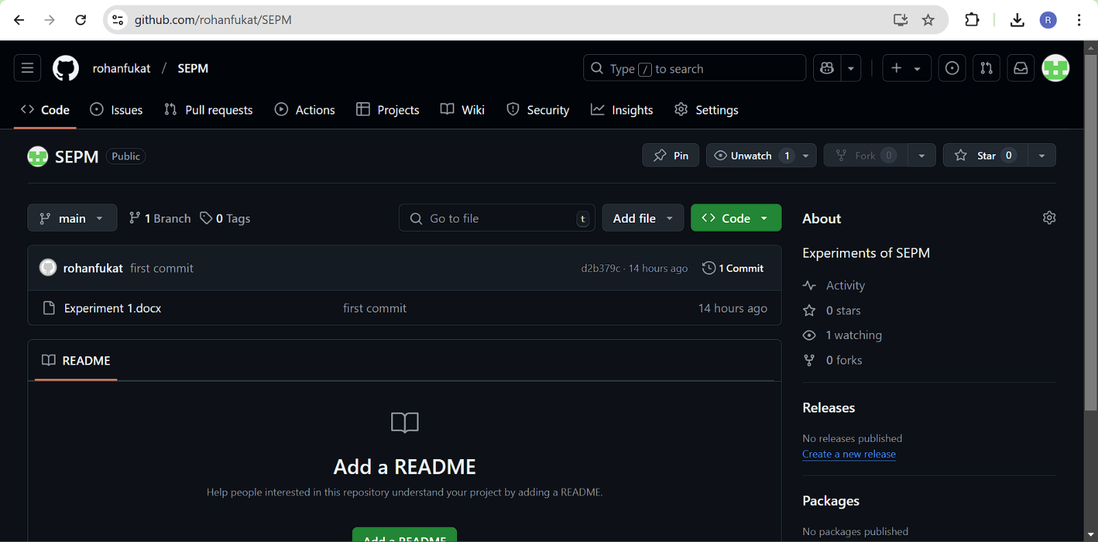

**Conclusion:** Thus, we have successfully executed git operations on local and remote repositories